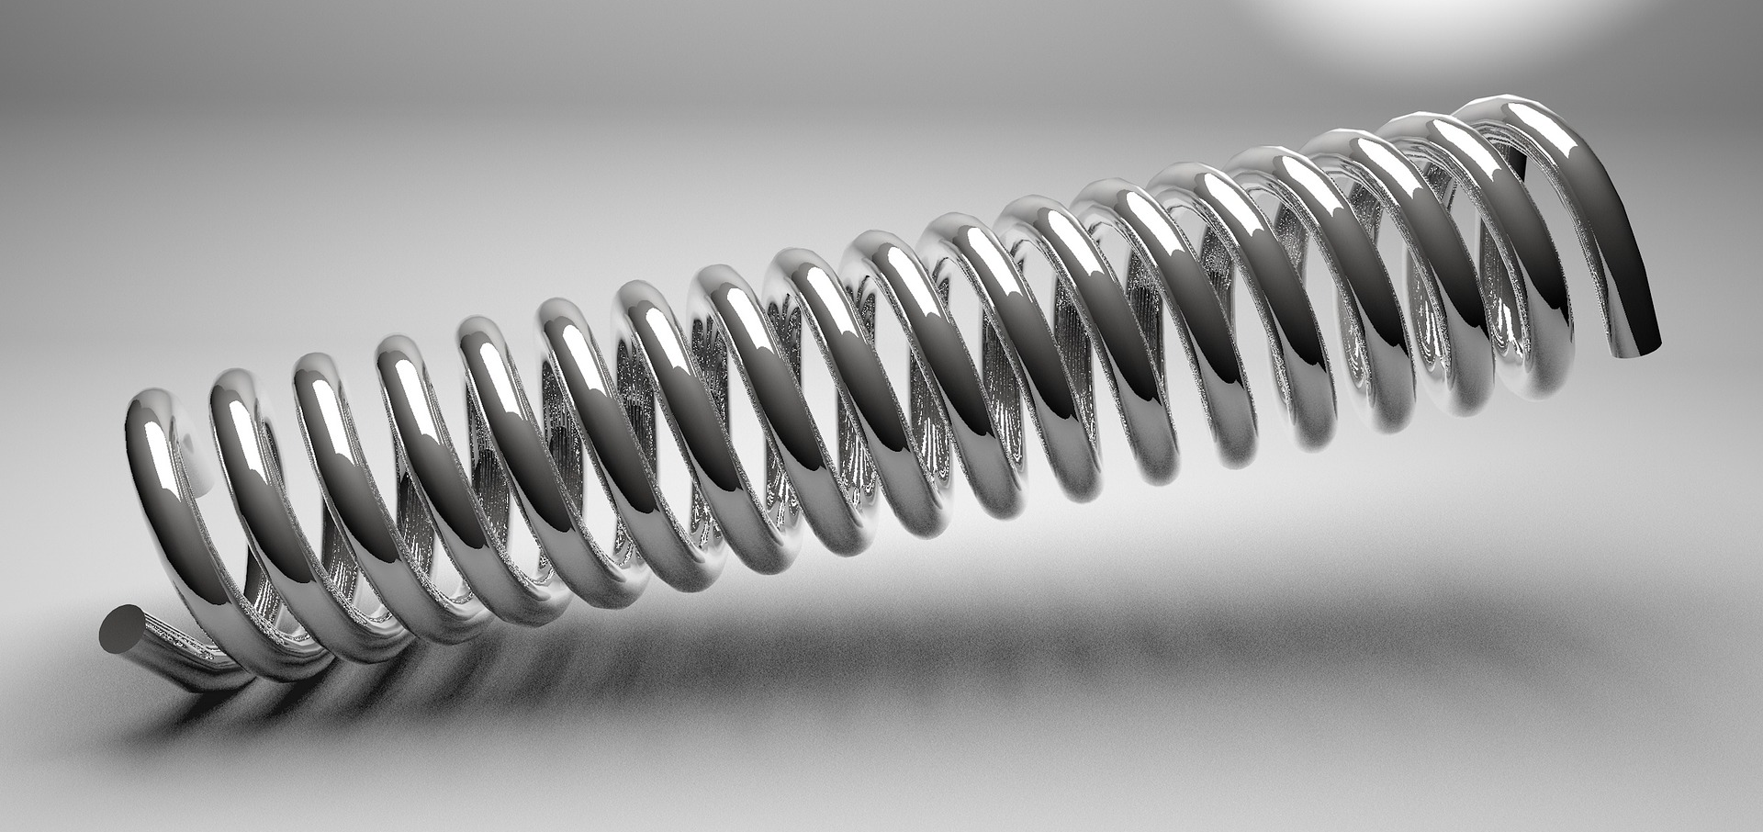

Lesson 3: Elastic potential energy
Keywords: spring constant, extension, joules.

Objectives:
A) Define elastic potential energy
B) Calculate elastic potential energy


C) Convert between elastic potential and other forms of energy
Objective A: Defining elastic potential energy

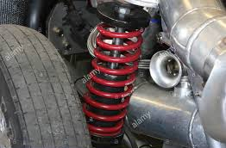
Starter
Which of these springs has a larger spring constant:
- Spring on a car’s suspension.
- Small (2cm) spring.

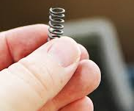

Elastic potential energy is the energy stored in a stretched, or compressed, spring or elastic material:

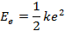
Elastic potential energy, in joules (J)
Spring constant, in newtons per metre (N/m)
Extension, in metres (m)

The spring constant is a measure of how much force is needed to stretch/compress the object.

Practice A: Defining elastic potential energy

- State the equation for elastic potential energy, defining the terms used.

- Write a sentence defining elastic potential energy in words.

- You join two springs together and hang a mass off the bottom of them. How does the extension of both springs compare to the extension of one?

- Describe the energy changes that occur when a rubber band is stretched, let go, flies straight up into the air and then falls back down to the ground.

Assessment A: Defining elastic potential energy

Which statements are true, and which are false?

A | A spring constant of 5 Nm means that it takes 5 Newtons of force to stretch the spring by 1 metre.
B | .
C | Elastic potential energy is directly proportional to the extension.
D | Spring constant has units of Nm, and extension has units of metres.

Objective B: Calculating elastic potential energy
Worked example 1

How much work must be done to compress a spring by 4.0 cm if the spring constant is 55 N/m.
Study tip
Don’t forget to convert non-standard units into standard units!
e = 4 cm = 0.04 m
conversion
k = 55 N/m

E_{e} = 0.5 x k x e²

E_{e} = 0.5 x 55 x 0.04²
units
E_{e} = 0.044 Joules

Worked example 2

A coil spring on a car’s suspension have a value of k = 64 kN/m. When the car strikes a bump the spring briefly stores 80 Joules of energy. How much does the spring compress?
conversion
k = 64 kN/m = 64,000 N/m
E_{e} =80
transformation
E_{e} = 0.5 x k x e² → e = √(E_{e} ÷ 0.5k)

e = √(80 ÷ (0.5 × 64,000))
E_{e} = 0.05 metres
Practice B: Calculating elastic potential energy
- Solve for each unknown.
- A spring with k = 45 N/m is compressed by 13 cm. How much energy is stored?
- A spring with k = 520 N/m stores 7.04 J. How far is it extended from the equilibrium position?
- A spring, when compressed 20 cm from the equilibrium position, stores 26 J. What is the value of the spring constant.

- A spring attached to a ceiling has a mass of 500 g suspended from it such that the spring stretches 4.0 cm. Calculate the spring constant. (g = 9.8 N/kg)

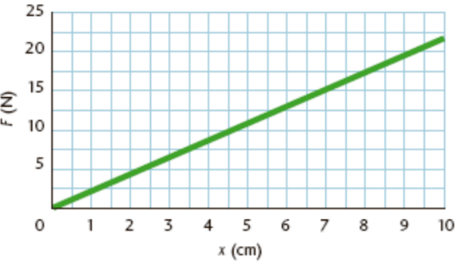
- To the right is a graph of F versus e for an elastic spring. Determine:
- The spring constant.
- The spring’s maximum amount of elastic potential energy.
- The change in elastic potential energy when the spring extends from 3 cm to 4 cm.

Assessment B: Calculating elastic potential energy
A | 230 m
B | 0.23 m
C | 0.46 m
D | 460 m
At maximum extension a bungee cord stores 2.0 × 10⁶ J of energy. A 10-kg mass extends the bungee cord 1.3 m. What is the maximum extension of the bungee cord?

Worked example 1
Objective C: Convert between elastic potential and other forms of energy
An elastic band of spring constant 5 N/m and mass 2 g is stretched by 15 cm and shot directly up in the air. Calculate the maximum height that the elastic band reaches.
Study tip
Don’t forget to convert into standard units!
conversion
e = 15 cm = 0.15 m
k = 5 N/m

E_{e} = 0.5 x k x e²

E_{e} = 0.5 x 5 x 0.15²
E_{e} = 0.056 Joules

The EPE is all converted into GPE; therefore the GPE is also 2 x 10⁻⁶ Joules.

E_{p} = m x g x h

m = 2 g = 0.002 kg
g = 9.8 N/kg
E_{p} = 0.056 Joules
transformation
h = E_{p} ÷ (m x g)

h = 0.056 ÷ ( 0.002 x 9.8)
units
h = 2.9 metres

Practice C: Convert between elastic potential and other forms of energy

- An arrow of mass 300g is shot directly upwards by a bow of spring constant 2000 N/m, that is extended by a distance of 20 cm. Calculate:
- The maximum elastic potential energy stored by the bow.
- The initial velocity of the arrow.
- The maximum height that the arrow reaches. (g = 9.8 N/kg)

- A student stretches (by 20 cm) an elastic band of spring constant 20 N/m and mass 5g directly at the teacher. The student gets 10 minutes of detention for each metre/second of velocity that it hits the teacher with. How long is the student’s detention?

Assessment C: Convert between elastic potential and other forms of energy

A boy bounces on a pogo stick (total mass 40 kg) of spring constant 3200 N/m. If the pogo stick is compressed by 50 cm, and all elastic potential energy is converted into gravitational potential energy; how high does the boy reach?
A | 1.02 m
B | 1002 m
C | 2.04 m
D | 0.102 m

